**4.What is nested loops in python?**

**Objective:**

* To see how to achieve nested loop using python3.

**Process:**

* Use loop within the loop.
* Elif conditions.
* Else conditions.

**Input:**

* Sample code to check whether given number is odd or even using if and elif.
* Sample code to find prime numbers in a given interval using for, if and else.

**Output:**

* Given input is odd or even.
* Prime numbers in between a interval.

**Source code** (check odd or even):

#get input from user

n=int(input("Enter the number:"))

#initialize the loop with condition

if(n>0):

#another loop with in the loop

if(n%2==0):

print("Given number is even")

#nested loop

elif(n%2!=0):

print("Given number is odd")

print()

**Source code**(Find prime numbers in a interval):

#get the lower limit

l=int(input("Enter the lower limit:"))

#get the upper limit

u=int(input("Enter the upper limit:"))

#initialize the loop conditions

for i in range(l,u+1):

#anothe if loop within for loop

if (i>1):

#another loop

for j in range(2,i):

if (i%j==0):

break

#else statement

else:

print(i)

**Screen shots:**

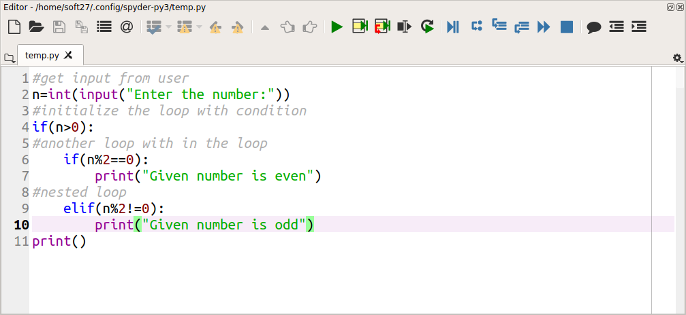

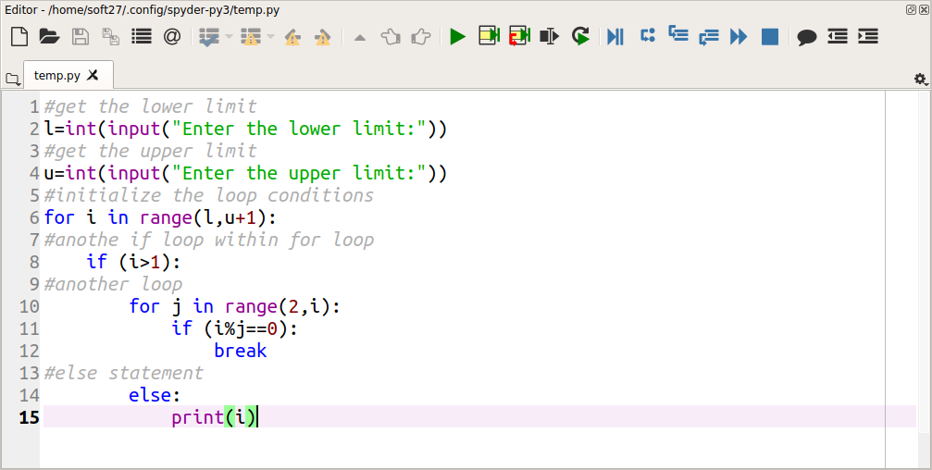

**Output:**

